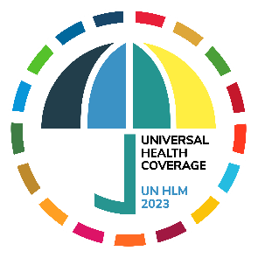

From Commitment to Action: The UN High-Level Meeting on Universal Health Coverage in September 2023

[Date]
Dear [insert name],

In September 2023, the 78th United Nations General Assembly will hold three high-level meetings (UN HLM) on health. These meetings provide all countries an opportunity to reinvigorate progress on universal health coverage (UHC) and health for all.

Your engagement between now and the UN HLM on UHC on September 21, 2023, is critical to ensuring leaders move from commitment to action. We call on you to:
- Commit to the highest political level participation at the UN HLM on UHC;
- Ensure synergies across the three 2023 UN HLMs on UHC, tuberculosis and pandemic prevention, preparedness, and response; and promote coherent, integrated and action-oriented global health agendas; and
- Make ambitious, actionable commitments—as outlined in the Action Agenda from the UHC Movement—to ensure UHC becomes a reality for all.

In line with the UHC HLM modalities resolution, we urge [Country this letter is addressed to] to assemble a gender-balanced national delegation and to include key stakeholders such as parliamentarians, mayors and governors, representatives of civil society, including non-governmental organizations, indigenous leadership, community organizations and faith-based organizations, academia, philanthropic foundations, the private sector and universal health coverage networks.

To ensure renewed effort on implementing political commitments made in September 2019, we further call your attention to the eight areas outlined in detail in an Action Agenda developed by the UHC Movement after an extensive multi-stakeholder consultation (see Annex).

We respectfully ask for your support in elevating this Action Agenda to the highest level of political dialogue ahead of and during the UN HLM.

We look forward to further discussing with you actionable commitments that will strengthen health systems, based on a primary health care approach, to deliver health security, universal health coverage and health for all.

Yours sincerely,
[Name]
To cc: [Insert names]

